PHP Assignment

1.  AIM:Write a script to display Fibonacci numbers up to given term.

<h2>Name : Mishra Sandip Manoj</h2>

<h2>Enrollment No : 229768307002</h2>

<?php

$a *=* 0;

$b *=* 1;

echo "<h3>Fibonacci :-</h3> <br>  $a <br> $b <br>";

*for* ($i *=* 3; $i *<=* 10; $i*++*) {

    $c *=* $a *+* $b;

    echo " $c <br>";

    $a *=* $b;

    $b *=* $c;

}

?>

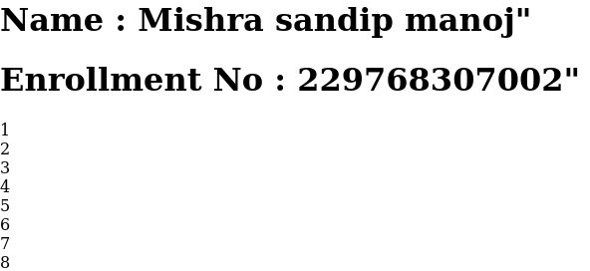

2.  AIM:Write a script to display the merge to string.

<h2>Name : Mishra Sandip Manoj</h2>

<h2>Enrollment No : 229768307002</h2>

<?php

$a *=* 'Sandip';

$b *=*  7002 ;

echo "Name : $a <br> Number : $b";

?>



3.  AIM:Write a script to display a multiplication table for the given number

<h2>Name : Mishra Sandip Manoj</h2>

<h2>Enrollment No : 229768307002</h2>

<form *method*="get">

    <label *for*="Num-1">Table</label>

    <input *type*="number" *name*="Num-1"></input>

    <button *type*="submit" *name*="sub"> Submit </button>

</form>

<?php

*if* (isset($_GET['sub'])) {

    $x *=* $_GET['Num-1'];

*for* ($i *=* 1; $i *<=* 10; $i*++*) {

        $t *=* $x *\** $i;

        echo "$x X $i = $t <br>";

    }

}

?>

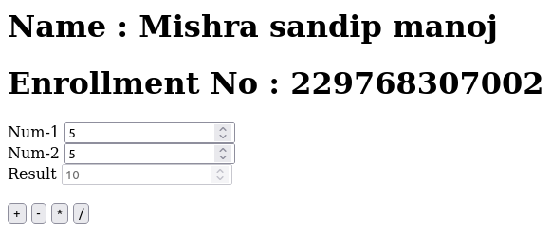

4.  AIM:Write a script to implement Simple Calculator for mathematical operations.

<?php

*if* (isset($_GET['op'])) {

    $a *=* $_GET['Num-1'];

    $b *=* $_GET['Num-2'];

    $op *=* $_GET['op'];

    $result *=* 0;

*if* (is_numeric($a) *&&* is_numeric($b)) {

*switch* ($op) {

*case* 'add':

                $result *=* $a *+* $b;

*break*;

*case* 'sub':

                $result *=* $a *-* $b;

*break*;

*case* 'mul':

                $result *=* $a *\** $b;

*break*;

*case* 'div':

                $result *=* $a */* $b;

*break*;

        }

    }

*else* {

        echo "enter numeric value";

    }

}

?>

<h1>Name : Mishra sandip manoj</h1>

<h1>Enrollment No : 229768307002</h1>

<form *action*="<?= $_SERVER['PHP_SELF'] ?>" *method*="get">

    <label *for*="Num-1">Num-1</label>

    <input *type*="number" *name*="Num-1" *id*="num1" *value*="<?= $a ?>"></input>

    <br>

    <label *for*="Num-2">Num-2</label>

    <input *type*="number" *name*="Num-2" *id*="num2" *value*="<?= $b ?>"></input>

    <br>

    <label *for*="Result">Result</label>

    <input *type*="number" *name*="Result" *id*="result" *value*="<?= $result ?>" *disabled*></input>

    <br><br>

    <button *type*="submit" *name*="op" *value*="add"> + </button>

    <button *type*="submit" *name*="op" *value*="sub"> - </button>

    <button *type*="submit" *name*="op" *value*="mul"> * </button>

    <button *type*="submit" *name*="op" *value*="div"> / </button>

</form>

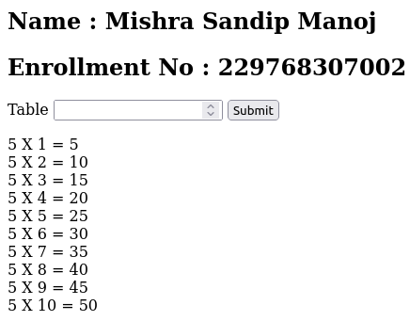

5.  AIM:Write a script that reads the name of the car and displays the name of the company the car belongs to.

<h1>Name : Mishra sandip manoj</h1>

<h1>Enrollment No : 229768307002</h1>

<form>

        <label *for*="car">Select Your Company</label><br><br>

        <select *name*="car">

            <option *value*="bmw">Bmw</option>

            <option *value*="mer">Mercides</option>

            <option *value*="suzu">Suzuki</option>

            <option *value*="mahi">Mahindra</option>

        </select>

        <br><br>

        <button *type*="submit" *name*="submit" *value*="submit">Submit</button>

</form>

<?php

*if* (isset($_GET['submit'])) {

    $a *=* $_GET['car'];

*switch* ($a) {

*case* 'bmw':

            echo "This all are models of BMW.<br>";

            echo "<br>x1<br>x2<br>x3<br>x4<br>x5";

*break*;

*case* 'mer':

            echo "This all are models of Mercides.<br>";

            echo "<br>S-Maybach<br>4-matic<br>GLS<br>Amg";

*break*;

*case* 'suzu':

            echo "This all are models of Maruti-Suzuki.<br>";

            echo "<br>Waganar<br>shift<br>Desire<br>Alto 800";

*break*;

*case* 'mahi':

            echo "This all are models of Mahindra.<br>";

            echo "<br>Thar<br>XUV 500<br>Scorpio<br>XUV 700";

*break*;

    }

}

?>

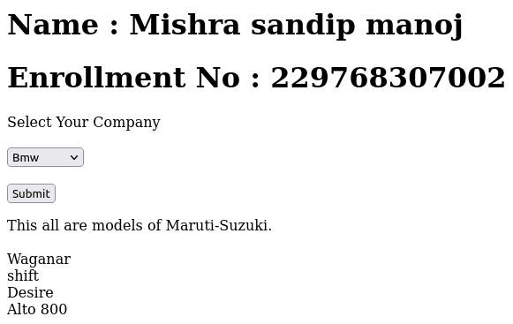

6.  AIM:Write a script to take the basic salary of an employee as input and calculate the net payment to any employee.

<h1>Name : Mishra sandip manoj"</h1>

<h1>Enrollment No : 229768307002"</h1>

<form *method*="post">

    <div>

        <label *for*="salary">Salary</label>

        <input *type*="text" *name*="salary" *id*="salary" *value*=""></input>

        <button *type*="submit" *name*="submit" *value*="submit">Submit</button>

    </div>

</form>

<?php

*if* (isset($_POST['submit'])) {

    $basic_salary *=* $_POST['salary'];

    $dallowance *=* 0.50 *\** $basic_salary;

    $house_rent *=* 0.10 *\** $basic_salary;

    $medical *=* 0.04 *\** $basic_salary;

    $gross_salary *=* $basic_salary *+* $dallowance *+* $house_rent *+* $medical;

    $insurance *=* 0.07 *\** $gross_salary;

    $pf *=* 0.05 *\** $gross_salary;

    $deduction *=* $insurance *+* $pf;

    $net_salary *=* $gross_salary *-* $deduction;

    echo "Basic_salary:" *.* "$basic_salary" *.* "<br>";

    echo "DA:" *.* "$dallowance" *.* "<br>";

    echo "HRA:" *.* "$house_rent" *.* "<br>";

    echo "Medical:" *.* "$medical" *.* "<br>";

    echo "Gross_salary:" *.* "$gross_salary" *.* "<br>";

    echo "Insurance:" *.* "$insurance" *.* "<br>";

    echo "PF:" *.* "$pf" *.* "<br>";

    echo "Deduction:" *.* "$deduction" *.* "<br>";

    echo "Net_salary:" *.* "$net_salary" *.* "<br>";

}

?>

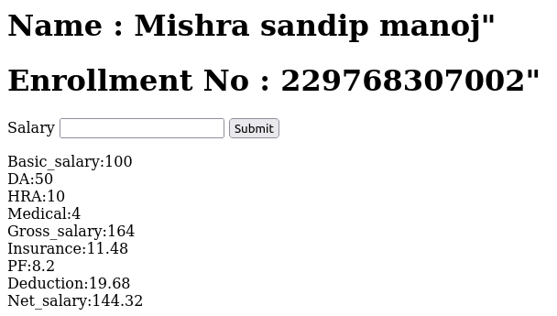

7.  AIM: Write a script to read the marks of 4 subjects and display the result.

<h1>Name : Mishra sandip manoj"</h1>

<h1>Enrollment No : 229768307002"</h1>

<form *action*="<?= $_SERVER['PHP_SELF'] ?>" *method*="get">

    <label *for*="OS">OS :- </label> <br>

    <input *type*=" number " *name*="OS" *id*="OS" *value*=""><br> <br>

    <label *for*="PYTHON">PYTHON :- </label> <br>

    <input *type*=" number " *name*="PYTHON" *id*="PYTHON" *value*=""><br> <br>

    <label *for*="CN">CN :- </label> <br>

    <input *type*=" number " *name*="CN" *id*="CN" *value*=""><br> <br>

    <label *for*="IWD">IWD :- </label> <br>

    <input *type*=" number " *name*="IWD" *id*="IWD" *value*=""><br> <br>

    <br>

    <div>

        <button *type*="submit" *name*="submit" *value*="submit">Submit</button>

</form>

<?php

*if* (isset($_GET['submit'])) {

    $a *=* $_GET['OS'];

    $b *=* $_GET['PYTHON'];

    $c *=* $_GET['CN'];

    $d *=* $_GET['IWD'];

    $sum *=* $a *+* $b *+* $c *+* $d;

    $per *=* $sum */* 4 *\** 100;

*if* ($a *<=* 35 *||* $b *<=* 35 *||* $c *<=* 35 *||* $d *<=* 35) {

        echo "Fail";

    } *else* {

*if* ($per *>=* 85) {

            echo "AA";

        } *elseif* ($per *>=* 75) {

            echo "AB";

        } *elseif* ($per *>=* 65) {

            echo "BB";

        } *elseif* ($per *>=* 55) {

            echo "BC";

        } *elseif* ($per *>=* 45) {

            echo "CC";

        } *elseif* ($per *>=* 40) {

            echo "CD";

        } *elseif* ($per *>=* 35) {

            echo "DD";

        }

    }

}

?>

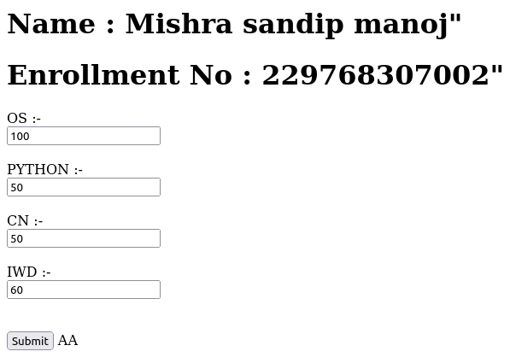

8.  AIM: Write a script to calculate the length of a string and count the number of Words in the given string Without using string functions.

<h1>Name : Mishra sandip manoj"</h1>

<h1>Enrollment No : 229768307002"</h1>

<?php

$a *=* "String";

$i *=* 0;

*while* (*@*$a[$i*++*] *!=* Null);

$i*--*;

echo "'$a' word's length is :$i";

?>

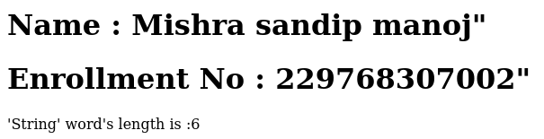

9.  AIM: Write a script to calculate the length of a string and count the number of Words in the given string With using string functions.

<h1>Name : Mishra sandip manoj"</h1>

<h1>Enrollment No : 229768307002"</h1>

<?php

$a *=* "String";

$len *=* strlen($a);

echo " '$a' word's length is :$len";

?>

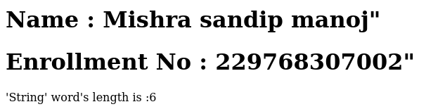

10. AIM: Write a script to sort a given indexed array.

<h1>Name : Mishra sandip manoj"</h1>

<h1>Enrollment No : 229768307002"</h1>

<?php

$a *=* array(2,1,4,3,7,5,8,6);

sort($a);

*foreach* ($a *as* $value) {

    echo "$value<br>";

}

?>

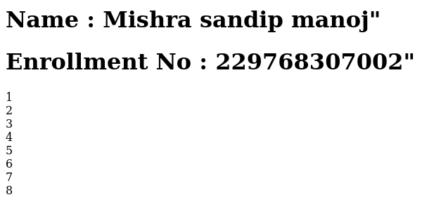

11. AIM: Write a script to perform 3 x 3 matrix Multiplication.

<h2>Name : Mishra Sandip Manoj</h2>

<h2>Enrollment No : 229768307002</h2>

<?php

$a *=* array(

    array(1, 2, 3),

    array(1, 2, 3),

    array(1, 2, 3)

);

$b *=* array(

    array(1, 2, 3),

    array(1, 2, 3),

    array(1, 2, 3)

);

$r *=* array(

    array(0, 0, 0),

    array(0, 0, 0),

    array(0, 0, 0)

);

*for* ($i *=* 0; $i *<* 3; $i*++*) {

*for* ($j *=* 0; $j *<* 3; $j*++*) {

*for* ($k *=* 0; $k *<* 3; $k*++*) {

            $r[$i][$j] *=* $a[$i][$k] *\** $b[$k][$j];

        }

    }

}

*for* ($i *=* 0; $i *<* 3; $i*++*) {

*for* ($j *=* 0; $j *<* 3; $j*++*) {

        echo $r[$i][$j];

    }

    echo "<br>";

}

?>

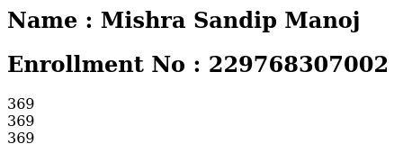

12. AIM: Write a script to encode a given message into equivalent Morse code.

<h2>Name : Mishra Sandip Manoj</h2>

<h2>Enrollment No : 229768307002</h2>

<?php

$string *=* "dog";

$string_lower *=* strtolower($string);

$assoc_array *=* array(

    "a" *=>* ".-",

    "b" *=>* "-...",

    "c" *=>* "-.-.",

    "d" *=>* "-..",

    "e" *=>* ".",

    "f" *=>* "..-.",

    "g" *=>* "--.",

    "h" *=>* "....",

    "i" *=>* "..",

    "j" *=>* ".---",

    "k" *=>* "-.-",

    "l" *=>* ".-..",

    "m" *=>* "--",

    "n" *=>* "-.",

    "o" *=>* "---",

    "p" *=>* ".--.",

    "q" *=>* "--.-",

    "r" *=>* ".-.",

    "s" *=>* "...",

    "t" *=>* "-",

    "u" *=>* "..-",

    "v" *=>* "...-",

    "w" *=>* ".--",

    "x" *=>* "-..-",

    "y" *=>* "-.--",

    "z" *=>* "--..",

    "0" *=>* "-----",

    "1" *=>* ".----",

    "2" *=>* "..---",

    "3" *=>* "...--",

    "4" *=>* "....-",

    "5" *=>* ".....",

    "6" *=>* "-....",

    "7" *=>* "--...",

    "8" *=>* "---..",

    "9" *=>* "----.",

    "." *=>* ".-.-.-",

    "," *=>* "--..--",

    "?" *=>* "..--..",

    "/" *=>* "-..-.",

    " " *=>* " "

);

*for* ($i *=* 0; $i *<* strlen($string_lower); $i*++*) {

*foreach* ($assoc_array *as* $letter *=>* $code) {

*if* ($letter *==* $string_lower[$i]) {

            echo "$code<br/>";

        }

    }

}

?>



13. AIM: Consider a currency system in Which there are notes of 7 denominations, namely Rs. 1, Rs. 2, Rs. 5, Rs. 10, Rs. 20, Rs. 50 and Rs. 100. Write a function that computes the smallest number of notes that Will combine for a given amount of money.

<h2>Name : Mishra Sandip Manoj</h2>

<h2>Enrollment No : 229768307002</h2>

<?php

function countCurrency($amount)

{

    $notes *=* array(2000, 500, 200, 100, 50, 20, 10, 5, 1);

    $noteCounter *=* array(0, 0, 0, 0, 0, 0, 0, 0, 0, 0);

*for* ($i *=* 0; $i *<* 9; $i*++*) {

*if* ($amount *>=* $notes[$i]) {

            $noteCounter[$i] *=* intval($amount */* $notes[$i]);

            $amount *=* $amount *%* $notes[$i];

        }

    }

    echo ("Currency Count :-- <br><br>");

*for* ($i *=* 0; $i *<* 9; $i*++*) {

*if* ($noteCounter[$i] *!=* 0) {

            echo ($notes[$i] *.* " : " *.* $noteCounter[$i] *.* "<br>");

        }

    }

}

$amount *=* 868;

echo "<h4>Amount : $amount <br> </h4>";

countCurrency($amount);

?>

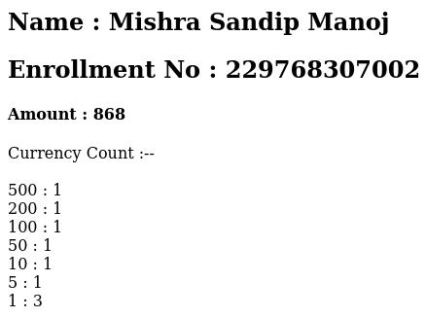

14. AIM: Write a script using string functions to check if the given string is loWercase or not.

<h2>Name : Mishra Sandip Manoj</h2>

<h2>Enrollment No : 229768307002</h2>

<?php

$a *=* "Hello";

echo strtolower($a);

?>



15. AIM: Write a script using string functions to reverse the given string.

<h2>Name : Mishra Sandip Manoj</h2>

<h2>Enrollment No : 229768307002</h2>

<?php

$str *=* "Hello";

echo strrev($str);

?>



16. AIM: Write a script using string functions to remove White space from the given string.

<h2>Name : Mishra Sandip Manoj</h2>

<h2>Enrollment No : 229768307002</h2>

<?php

$str *=* "Hello";

echo trim($str);

?>



17. AIM: Write a script using math functions to generate a random number betWeen the given range.

<h2>Name : Mishra Sandip Manoj</h2>

<h2>Enrollment No : 229768307002</h2>

<?php

$min *=* 1;

$max *=* 100;

echo (rand($min, $max));

?>



18. AIM: Write a script using math functions to display the binary, octal & hexadecimal of a given decimal number.

<h2>Name : Mishra Sandip Manoj</h2>

<h2>Enrollment No : 229768307002</h2>

<?php

$dec *=* 19;

echo "Binary:" *.* decbin($dec) *.* "<br>";

echo "Octal:" *.* decoct($dec) *.* "<br>";

echo "Hexadecimal:" *.* dechex($dec) *.* "<br>";

?>



19. AIM: Write a script using math functions to display the sin, cos & tan of a given number.

<h2>Name : Mishra Sandip Manoj</h2>

<h2>Enrollment No : 229768307002</h2>

<?php

$dec *=* 19;

echo "Binary:" *.* decbin($dec) *.* "<br>";

echo "Octal:" *.* decoct($dec) *.* "<br>";

echo "Hexadecimal:" *.* dechex($dec) *.* "<br>";

?>



20. Aim:-Write a script to display the current date and time in different formats

<h2>Name : Mishra Sandip Manoj</h2>

<h2>Enrollment No : 229768307002</h2>

<?php

$date *=* date('d-m-y h:i:s');

echo $date;

?>



21. Aim:- Write a script to define a class With constructor and destructor

<h2>Name : Mishra Sandip Manoj</h2>

<h2>Enrollment No : 229768307002</h2>

<?php

class MyClass

{

    public function __construct()

    {

        echo "Constructor called.<br>";

    }

    public function __destruct()

    {

        echo "Destructor called.<br>";

    }

}

$obj *=* *new* MyClass();

?>



22. Aim:- Write a script to create an object of a class and access its public properties and methods.

<h2>Name : Mishra Sandip Manoj</h2>

<h2>Enrollment No : 229768307002</h2>

<?php

class MyClass

{

    public $name *=* "Mishra Sandip";

    public $age *=* 30;

}

$obj *=* *new* MyClass();

echo "Name: " *.* $obj*->*name *.* "<br>";

echo "Age: " *.* $obj*->*age *.* "<br>";

?>



23. Aim:-Write a script that uses the set attribute and get attribute methods to access a class’s private attributes of a class

<h2>Name : Mishra Sandip Manoj</h2>

<h2>Enrollment No : 229768307002</h2>

<?php

class MyClass

{

    private $name;

    private $age;

    public function setName($name)

    {

        $this*->*name *=* $name;

    }

    public function setAge($age)

    {

        $this*->*age *=* $age;

    }

    public function getName()

    {

*return* $this*->*name;

    }

    public function getAge()

    {

*return* $this*->*age;

    }

}

*// Create an object of MyClass*

$obj *=* *new* MyClass();

*// Set values using setter methods*

$obj*->*setName("Mishra Sandip");

$obj*->*setAge(18);

*// Get values using getter methods*

echo "Name: " *.* $obj*->*getName() *.* "<br>";

echo "Age: " *.* $obj*->*getAge() *.* "<br>";

?>



24. Aim:- Write a script to demonstrate single inheritance

<h2>Name : Mishra Sandip Manoj</h2>

<h2>Enrollment No : 229768307002</h2>

<?php

class Animal

{

    public function eat()

    {

        echo "Animal is eating.<br>";

    }

}

class Dog extends Animal

{

    public function bark()

    {

        echo "Dog is barking.<br>";

    }

}

$dog *=* *new* Dog();

$dog*->*eat();

$dog*->*bark();

?>



25. Aim:- Write a script to demonstrate multiple inheritance

<h2>Name : Mishra Sandip Manoj</h2>

<h2>Enrollment No : 229768307002</h2>

<?php

interface Animal

{

    public function eat();

}

interface CanBark

{

    public function bark();

}

class Dog implements Animal, CanBark

{

    public function eat()

    {

        echo "Dog is eating.<br>";

    }

    public function bark()

    {

        echo "Dog is barking.<br>";

    }

}

$dog *=* *new* Dog();

$dog*->*eat();

$dog*->*bark();

?>



26. AIM: Write a script to demonstrate multilevel inheritance

<h2>Name : Mishra Sandip Manoj</h2>

<h2>Enrollment No : 229768307002</h2>

<?php

class A

{

    public function x()

    {

        echo "Sandip<br>";

    }

}

class B extends A

{

    public function y()

    {

        echo "Pradip<br>";

    }

}

class C extends B

{

    public function z()

    {

        echo "Sandy<br>";

    }

}

$c *=* *new* C();

$c*->*x();

$c*->*y();

$c*->*z();

?>



27. AIM: Write a script to demonstrate method overloading.

<h2>Name : Mishra Sandip Manoj</h2>

<h2>Enrollment No : 229768307002</h2>

<?php

class MyClass

{

    public function calculate($arg1, $arg2 *=* null)

    {

*if* ($arg2 *===* null) {

*return* $arg1 *\** 2;

        } *else* {

*return* $arg1 *+* $arg2;

        }

    }

}

$obj *=* *new* MyClass();

$result1 *=* $obj*->*calculate(5);

$result2 *=* $obj*->*calculate(5, 10);

echo "Result 1: " *.* $result1 *.* "<br>";

echo "Result 2: " *.* $result2 *.* "<br>";

?>



28. AIM: Write a script to demonstrate method overloading based on the number of arguments.

<h2>Name : Mishra Sandip Manoj</h2>

<h2>Enrollment No : 229768307002</h2>

<?php

class MyClass

{

    public function num($a, $b *=* null, $c *=* null)

    {

*if* ($c *!==* null) {

            $n *=* $a *+* $b *+* $c;

        } *elseif* ($b *!==* null) {

            $n *=* $a *+* $b;

        } *else* {

            $n *=* $a *\** 2;

        }

*return* $n;

    }

}

$obj *=* *new* MyClass();

$x *=* $obj*->*num(5);

$y *=* $obj*->*num(5, 10);

$z *=* $obj*->*num(5, 10, 15);

echo "Result 1: " *.* $x *.* "<br>";

echo "Result 2: " *.* $y *.* "<br>";

echo "Result 3: " *.* $z *.* "<br>";

?>



29. AIM: Write a script to demonstrate a simple abstract class.

<h2>Name : Mishra Sandip Manoj</h2>

<h2>Enrollment No : 229768307002</h2>

<?php

abstract class a

{

    abstract public function dis1();

    abstract public function dis2();

}

class b extends a

{

    public function dis1()

    {

        echo "Sandip";

    }

    public function dis2()

    {

        echo "<br> Mishra";

    }

}

$obj *=* *new* b();

$obj*->*dis1();

$obj*->*dis2();

?>



30. AIM: Write a script to demonstrate cloning objects.

<h2>Name : Mishra Sandip Manoj</h2>

<h2>Enrollment No : 229768307002</h2>

<?php

class x

{

    public $color;

    public $amount;

}

$obj *=* *new* x();

$obj*->*color *=* "Yellow";

$obj*->*amount *=* 50;

$copy *=* *clone* $obj;

echo ("Color : " *.* $obj*->*color *.* "<br>");

echo ("Amount : " *.* $obj*->*amount);

?>



31. AIM: Create a web page using a form to collect employee information..

<h2>Name : Mishra Sandip Manoj</h2>

<h2>Enrollment No : 229768307002</h2>

<form *method*="POST" >

    Enter EMP No: <br> <input *type*="text" *name*="eno"><br>

    Enter EMP Name: <br> <input *type*="text" *name*="name"><br>

    Enter Address: <br> <input *type*="text" *name*="addr"><br>

    <input *type*="submit" *value*="Submit">

</form>

<?php

session_start();

$_SESSION["eno"] *=* $_POST["eno"];

$_SESSION["name"] *=* $_POST["name"];

$_SESSION["addr"] *=* $_POST["addr"];

echo "Emp No: " *.* $_SESSION['eno'] *.* "<br>";

echo "Emp name: " *.* $_SESSION['name'] *.* "<br>";

echo "Address: " *.* $_SESSION['addr'] *.* "<br>";

?>

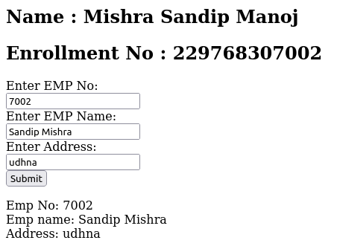

32. AIM: create a two distinct web pages to demonstrate information passing between them using URL- Get method.

<h1>Page 1</h1>

<h2>Name : Mishra sandip manoj</h2>

<h2>Enrollment No : 229768307002</h2>

<form *action*="32_5.php" *method*="GET">

    Enter your name: <input *type*="text" *name*="name"><br>

    Enter your age: <input *type*="number" *name*="age"><br>

    <input *type*="submit" *value*="Submit">

</form>

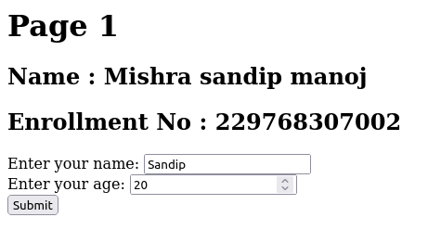

<h1>Page 2</h1>

<h2>Name : Mishra sandip manoj</h2>

<h2>Enrollment No : 229768307002</h2>

<p>Received information:</p>

<?php

$name *=* $_GET['name'];

$age *=* $_GET['age'];

echo "<p>Name: $name</p>";

echo "<p>Age: $age</p>";

?>



33. AIM: Create two different web pages to demonstrate information passing between web pages using Hidden variables – Post method

<h1>Page 1</h1>

<h2>Name : Mishra sandip manoj</h2>

<h2>Enrollment No : 229768307002</h2>

<form *action*="33_5.php" *method*="POST">

    <input *type*="hidden" *name*="name">

    <input *type*="hidden" *name*="age">

    <input *type*="submit" *value*="Submit">

</form>



<h1>Page 2</h1>

<h2>Name : Mishra sandip manoj</h2>

<h2>Enrollment No : 229768307002</h2>

<p>Received information:</p>

<?php

$name *=* $_POST['name'];

$age *=* $_POST['age'];

echo "<p>Name: $name</p>";

echo "<p>Age: $age</p>";

?>



34. AIM: Create web pages to demonstrate passing information using Session.

<h1>Page 1</h1>

<h2>Name : Mishra sandip manoj</h2>

<h2>Enrollment No : 229768307002</h2>

<p>Session variables set.</p>

<a *href*="34_5.php">Go to Page 2</a>

<?php

session_start();

$_SESSION['name'] *=* "Mishra Sandip Manoj";

$_SESSION['age'] *=* 20;

?>



<?php

session_start();

?>

<h1>Page 2</h1>

<h2>Name : Mishra sandip manoj</h2>

<h2>Enrollment No : 229768307002</h2>

<p>Received information from Page 1:</p>

<?php

*// Retrieve session variables*

$name *=* $_SESSION['name'];

$age *=* $_SESSION['age'];

echo "<p>Name: $name</p>";

echo "<p>Age: $age</p>";

?>



35. AIM: Write a script to convert an associative array into JSON string format and vice versa.

<h2>Name : Mishra sandip manoj</h2>

<h2>Enrollment No : 229768307002</h2>

<?php

$std *=* array(

    'Name' *=>* 'Sandip',

    'Enrollment Number' *=>* '229768307002',

    'Branch' *=>* 'Computer'

);

echo json_encode($std);

?>

